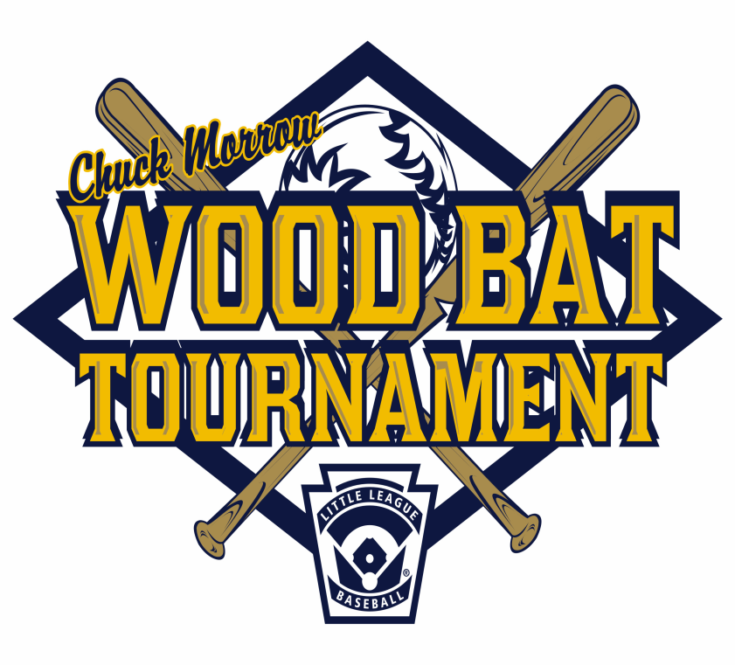
2015 Chuck Morrow Woodbat
Tournament

Open to all Junior Teams

Can form special Combined Play Teams
Must go through the League Player Agent/President and the District (Ezio or Kathy)

May include District 55

Cost will be $100 per team

Scheduled for Spring Break, April 4 through 12
No games on Easter Sunday

Entry forms due on March 28th

